Task 4

Login function.

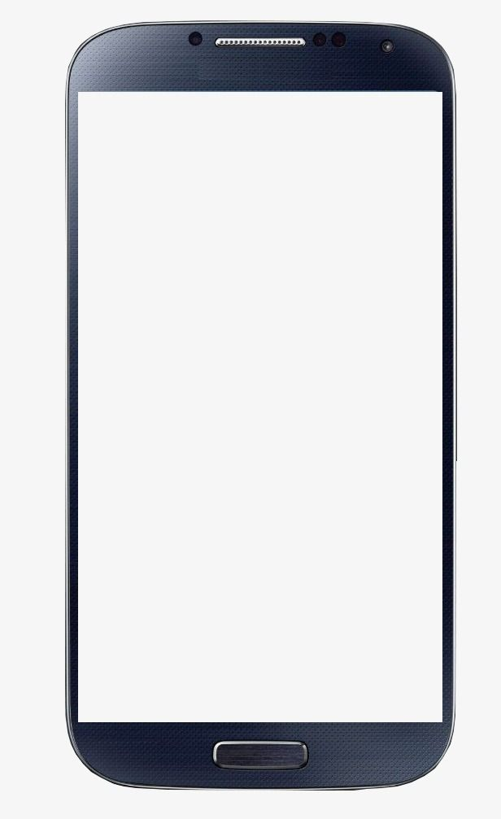

Create account

Eg.: Lim Chen Teik

Username

Eg. chenteik_99@hotmail.com

e-mail

At least 6 characters

Password

Re-enter Password

*********

Create Your Amazon Account

By creating an account, you agree to Amazon's [Conditions of Use](https://www.amazon.com/gp/help/customer/display.html/ref=ap_register_notification_condition_of_use?ie=UTF8&nodeId=508088) and [Privacy Notice](https://www.amazon.com/gp/help/customer/display.html/ref=ap_register_notification_privacy_notice?ie=UTF8&nodeId=468496)



Login Amazon Account

Username

Name. Eg. Lim Chen Teik

********

Password

Forget Password

Login

Help

Click help when password isn’t working and cannot create account.

Usability testing

How to know what is needed to fill in for e-mail?

What I need to do when I forgot password?

When you forget password, try to retrieve password.

What if I cannot create account?

How to do if my password isn’t working?

Advance Search function



Advance Search

keyword related to book name and book description. Eg. love, fire, food

Keywords

Author

Author of book. Eg. Dr. Y.V.Reddy

ISBN

All subject

Genre. Eg. Arts & Photography, Humor& Entertainment, Law, Comic & graphic Novel, Literature& Fiction

Languages

English, Spanish, German, Japanese, Malay, Chinese, etc.

Reader age

Baby-2 years, 3-5 years, 6-8 years, 9-12 years, 13-19 years. 20-60 years. 60 years above. (Finding the book suitable for your age)

Sort Result by

Best-selling. Price low to high. Price high to low. Avg. Customer review Publication Date

Search

back

International Standard Book Number. Eg. 978-3-16-148410-0

Usability testing

How to sort the searching result based on highest price to lowest price?

How do I search by author?

How do I search reader age which is 2 years old?

How do I search for English books?

How to back to the main page?